Adriann Liceralde and Jacob Larkin

Dr. Brian McPherson

August 23, 2021

Carbon Science Research at the University of Utah

Brief Update Regarding Sensor Nodes at Union Rooftop

**Location**

Below is a map of where the two sensor nodes (green and blue) are located. These nodes are monitoring an emission source (red).

**Figure 1. Map of Union Rooftop**

**Primary Node**

The primary node is marked in green in Figure 1. The red emission source is located about west-southwest of the sensor. Using Openair Analysis, a conditional bivariate polar plot is produced, shown below. According to this, an emission source is likely in the west-southwest direction.

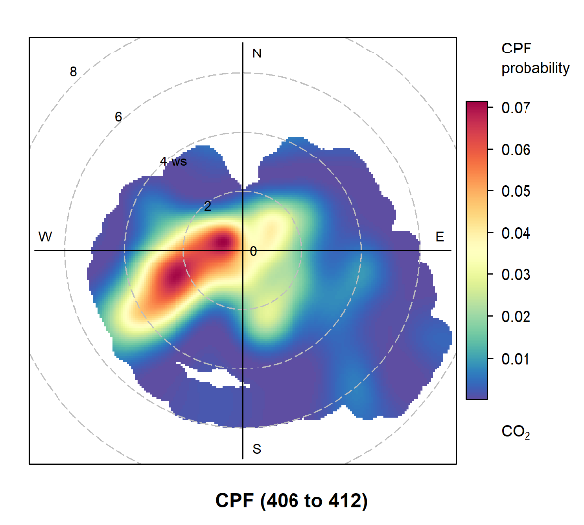

**Figure 2: Polar Plot of Primary Node**

**Secondary Node**

The secondary node is marked in blue in Figure 1. The emission source is about north-northwest of the sensor. Likewise, a plot is shown below, where an emission source is likely to be in the northwest direction.

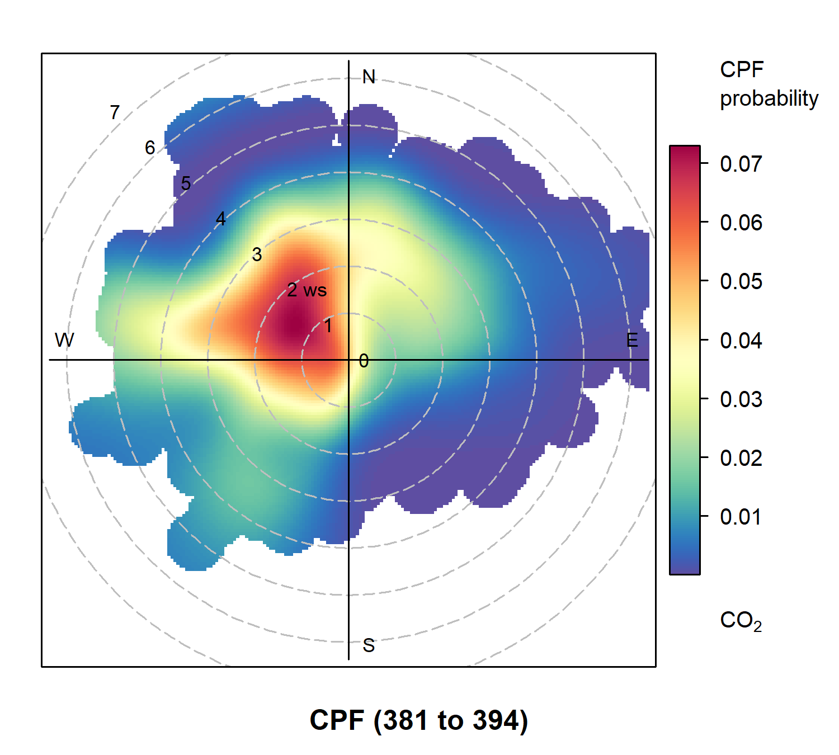

**Figure 3: Polar Plot of Secondary Node**

**Conclusion**

Each polar plot suggests an emission source in the direction of where the Panda Express Vent is located, relative to each node. Based on these initial data samples, we seem to be on the right track with our methods. However, more data needs to be collected to refine these plots. We also plan on upgrading the Arduino-based nodes to an Xbee-based node to improve functionality and give wireless communication capabilities.